Matthew Jolley

Chris Bischoff

# Software Design – Small ERP

## Classes UML



## Database Design



## Screen Shots of Unfinished Pages

I’m not finished with the design yet. I created a template so that all pages would match and so it would make it easier to make changes once I make a final decision on logos, colors, and layouts. Some pages required two screen shots so there is some overlay between those pictures. For example you may see “Add new product” twice.

### Default.aspx

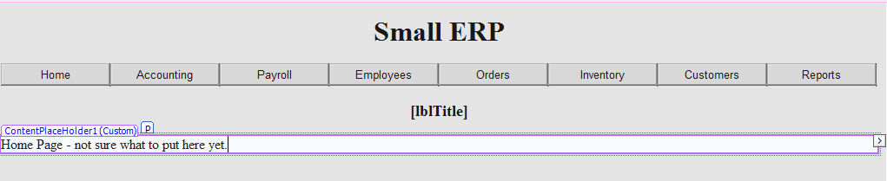

### Accounting.aspx

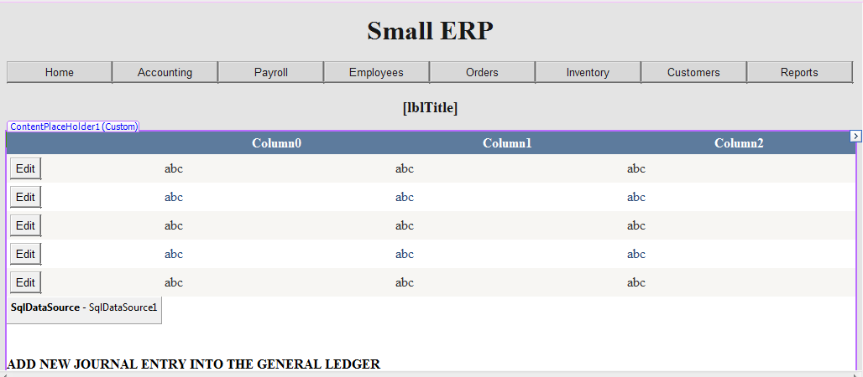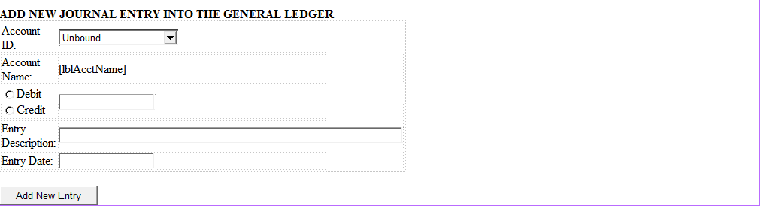

### Customers.aspx

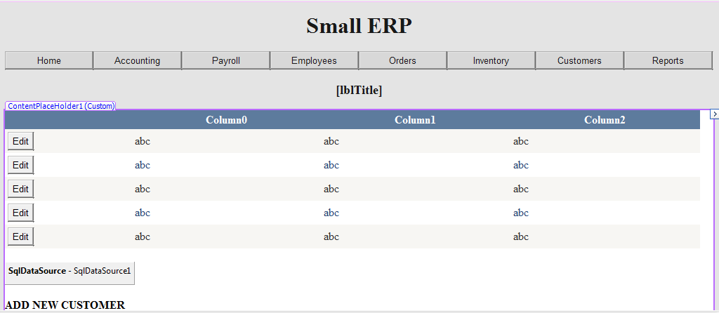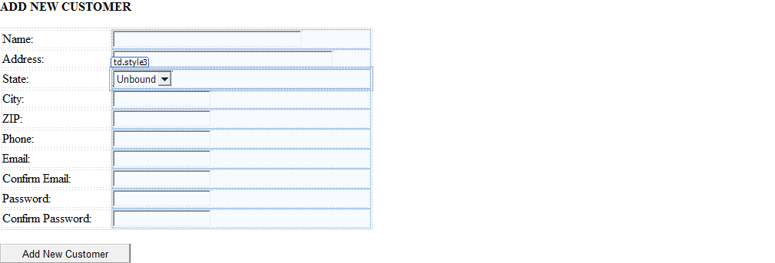

### Inventory.aspx

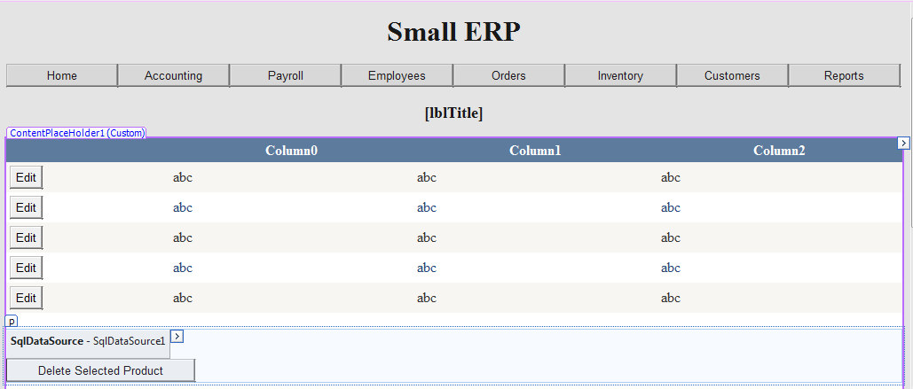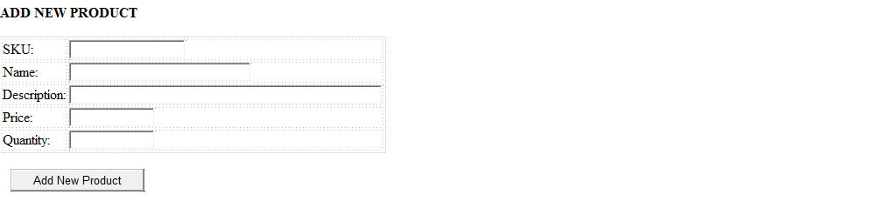

### Orders.aspx

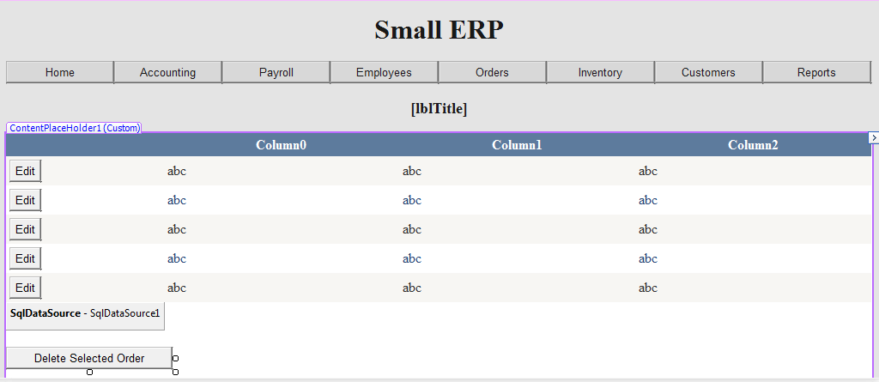

### Reports.aspx

